**Benefit Management & Financial Indicators Functionality Over OP2**

Financial indicator is the part of Particular object and it is visible in the benefit management tab in object workspace. Financial indicator **statistics extensively used to monitor the soundness, stability and performance of various sectors of the economy.**

After creation or existing Object go into the Object workspace and select tab Benefit management. In this we found three sections under this tab (Benefit Tracking, Financial Indicator and Project review process)

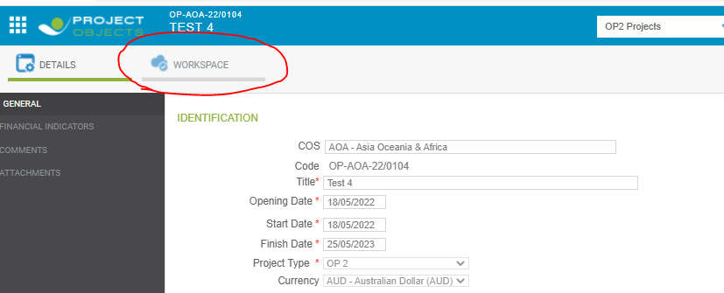

Step 1: Select Benefit Mngmt tab.

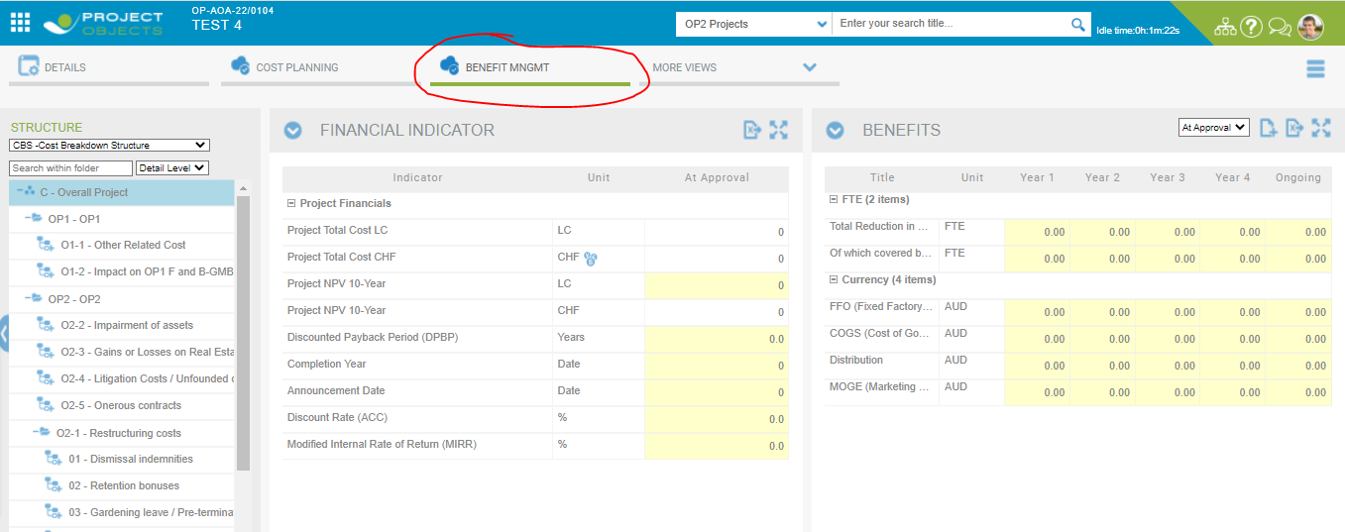

Above Screenshot Values of financial indicator is showing zero. Some values come from the Cost detail page, so firstly we select Cost planning tab and give the budget values.

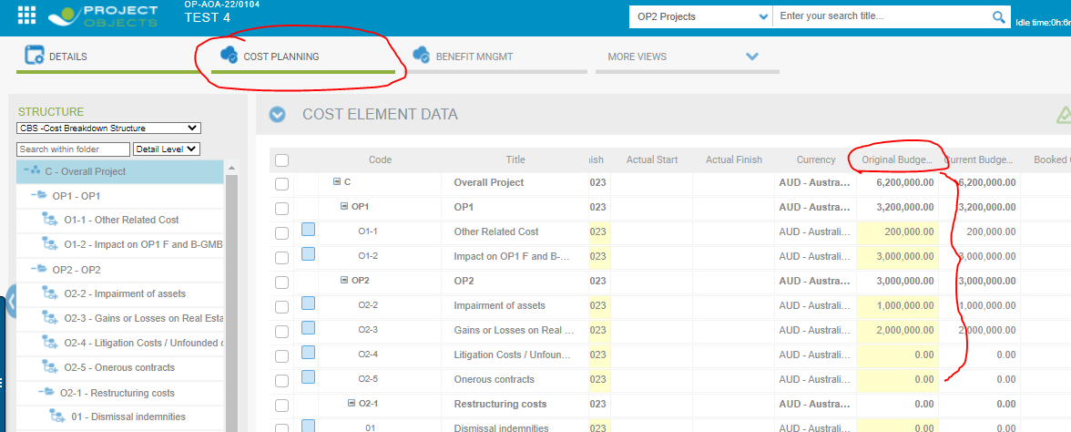

Here original value of Cost detail page is 6,200,000.00 would be visible in Financial indicator LC values and also with CHF values which is non-editable in the page.

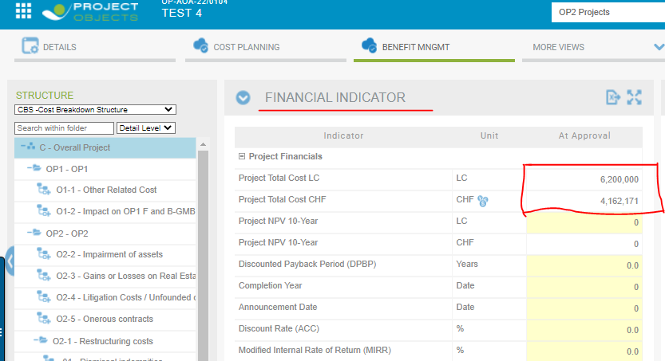

We give the values in all validate rows of the financial indicator.

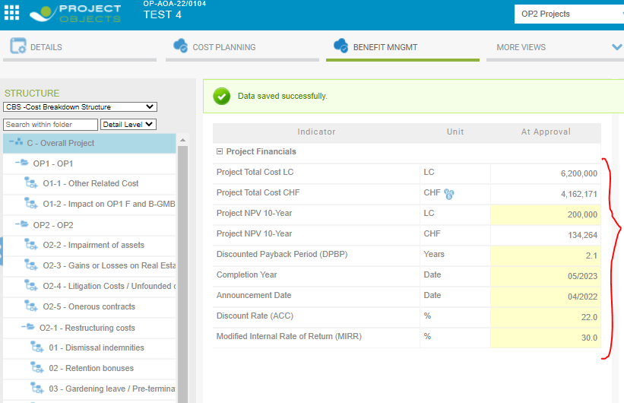

Values are save when you click outside of the cell.

Values of financial indicators also visible in Object Detail page in read only form in Financial Indicator section.

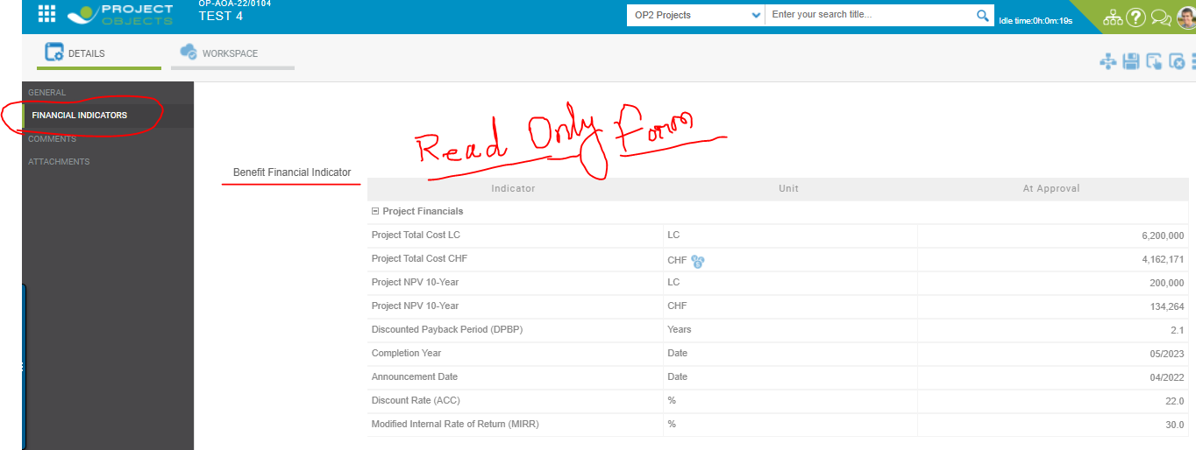

# **Review Column add in Financial Indicator.**

In Financial Indicator, Project process review (PRV) column will be added in the financial indicator after creation of review.

PRV will be created when the Object is visible in project register. So first we need to go in Project register and select checkbox in financial indicators section under object details page.

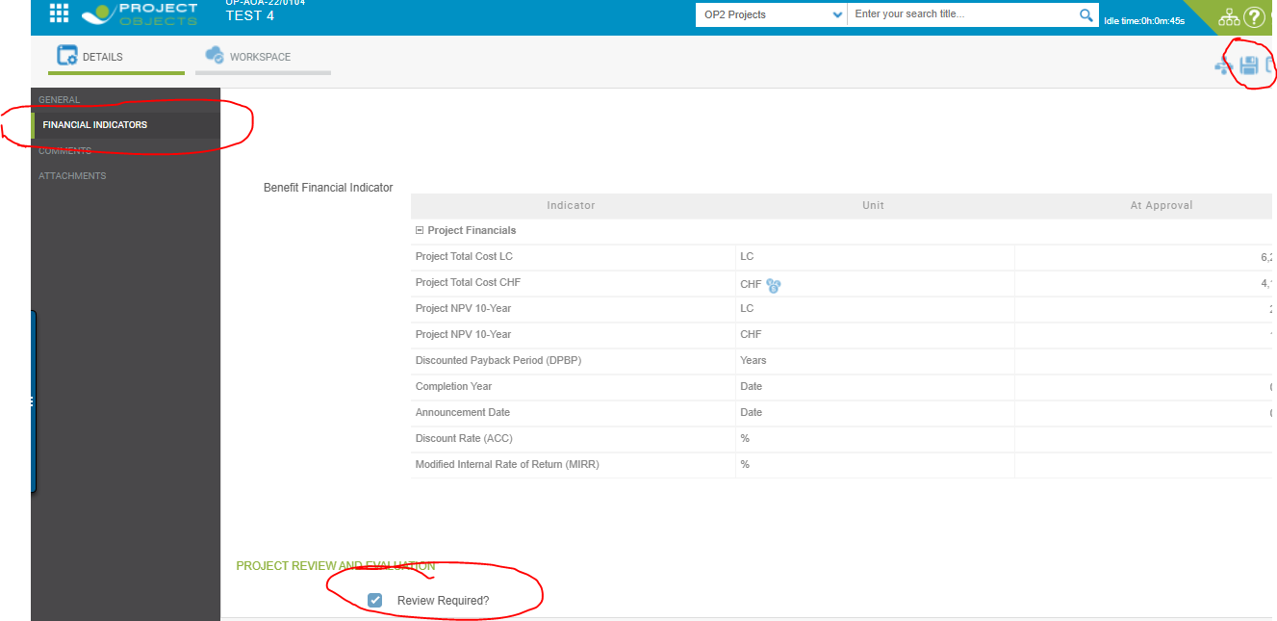

After this first we go to collaboration > Project Review Process

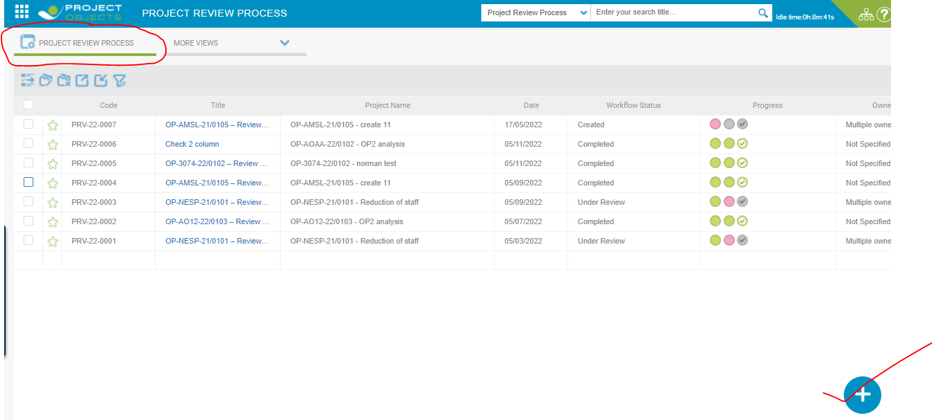

Fill the required fields in PRV.

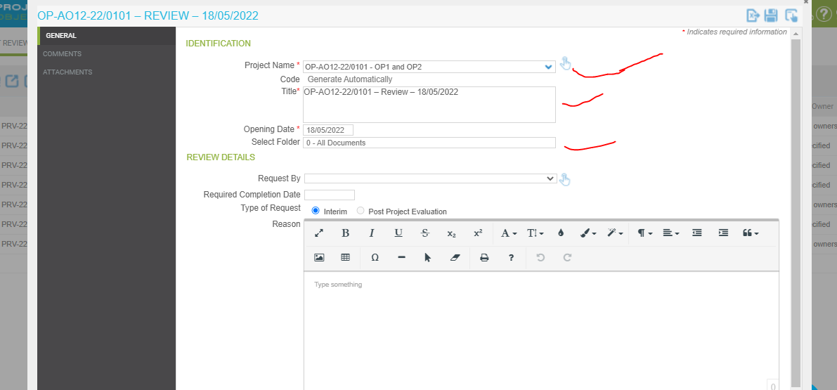

Now it will be visible PRV column in financial indicator.

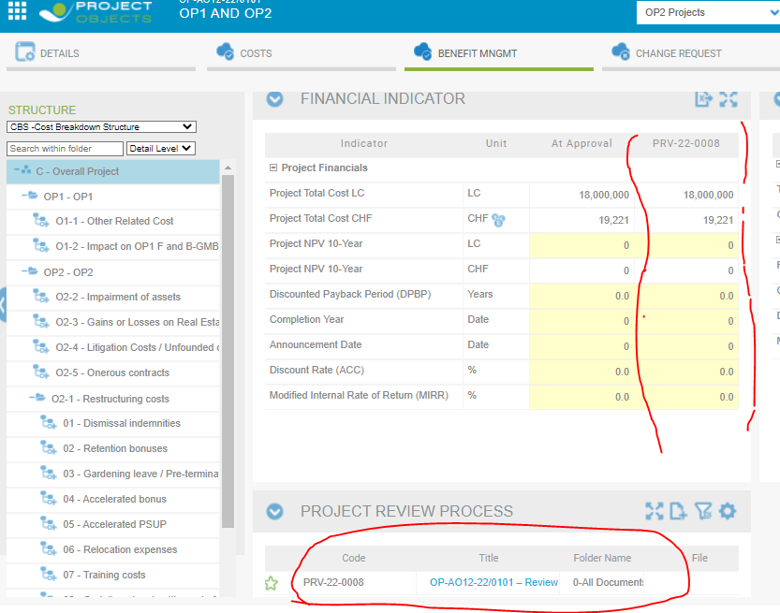

Then after fill-up all the conditional values in the PRV and release all the steps.

You will have to create PRV from two ways 1. Object Workspace 2. Collaboration.

You will have to create multiple types of PRV’s in Financial Indicator.

# **Benefit Tracking**

Select benefit management tab in Object workspace, here visible Benefit page.

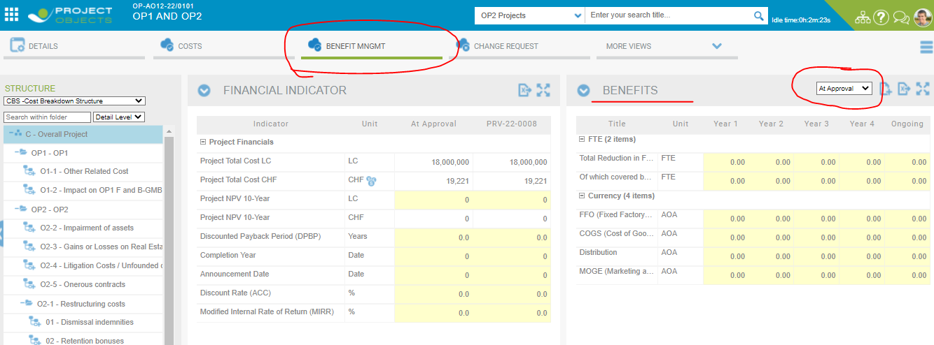

In Benefits page we can put the values At Approval dropdown.

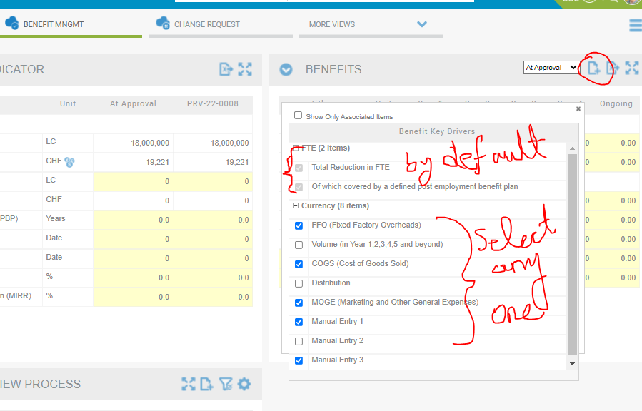

Whatever I select checkbox add icon , the selective items will be visible in Benefit page and that after fill the values in benefit AT APPROVAL.

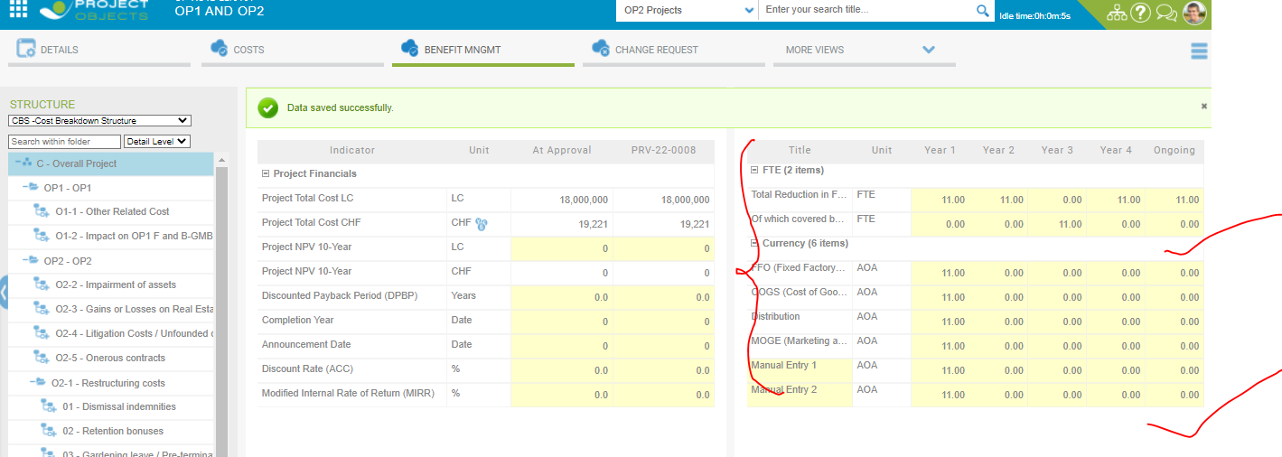

Now we create PRV.

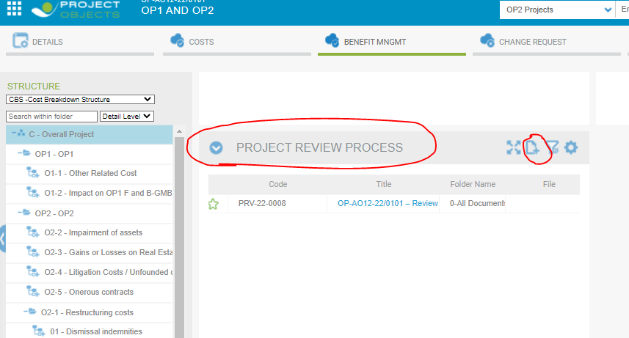



After creation of PRV, it is reflect in Three pages 1. PRV column add in financial indicator.

2. PRV code visible in dropdown Benefits page.

3. PRV is showing after creation Project Review Process.

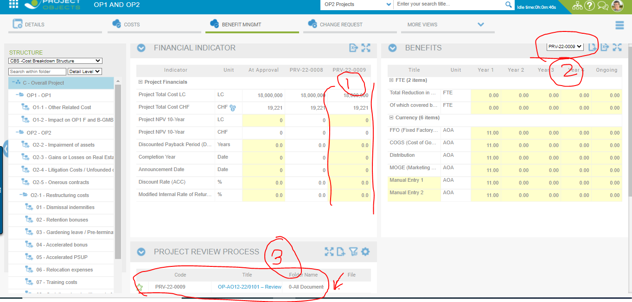

Multiple PRV’s created it will be visible in the benefits dropdown.

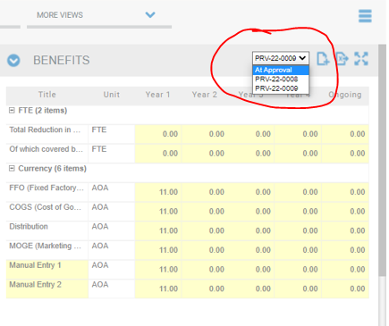

When we are put-up the values for PRV in benefit then AT Approval time of currencies values are also visible for that PRV and FTE columns data will not come. PRV-22-0009

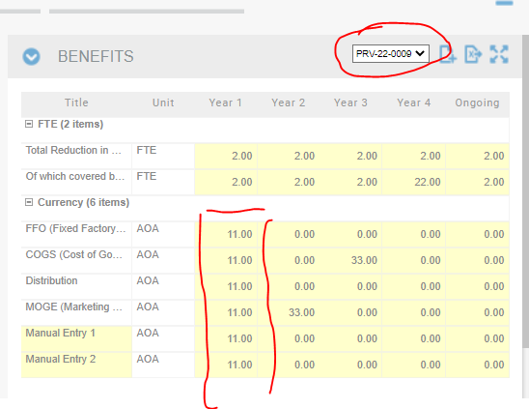

We release all the steps of Project review process.

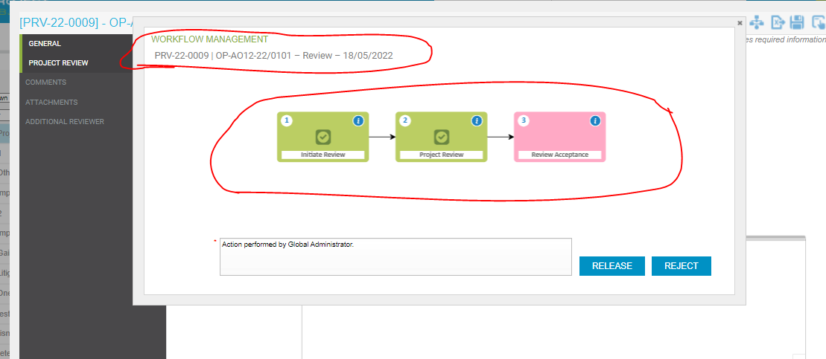

After released all the steps, then all benefit management page showing read only format of that PRV’s code.

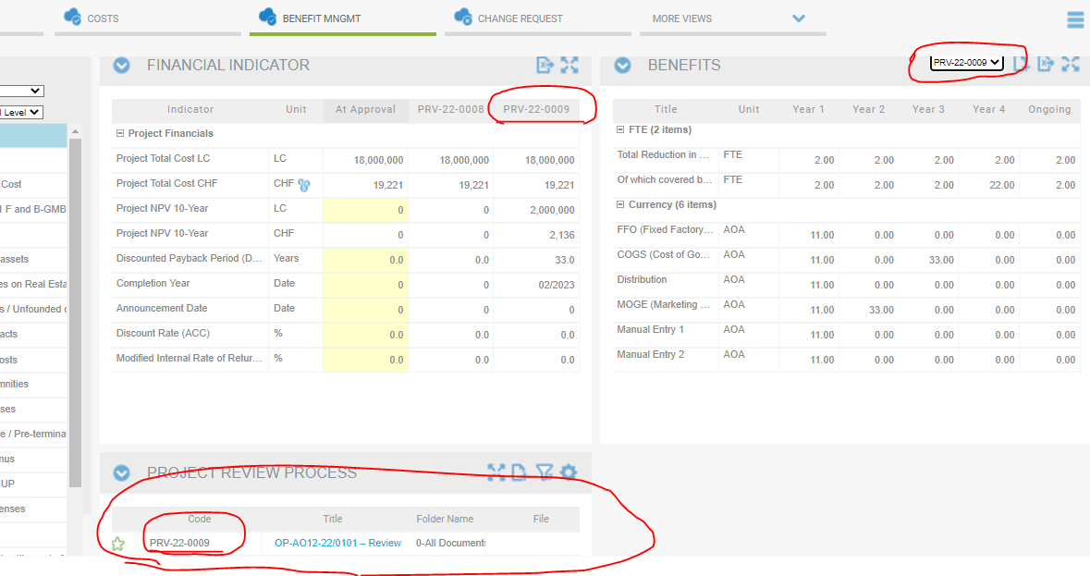

And Object details page, financial indicator section (Benefit tracking, financial indicators etc.) Always visible read only form.

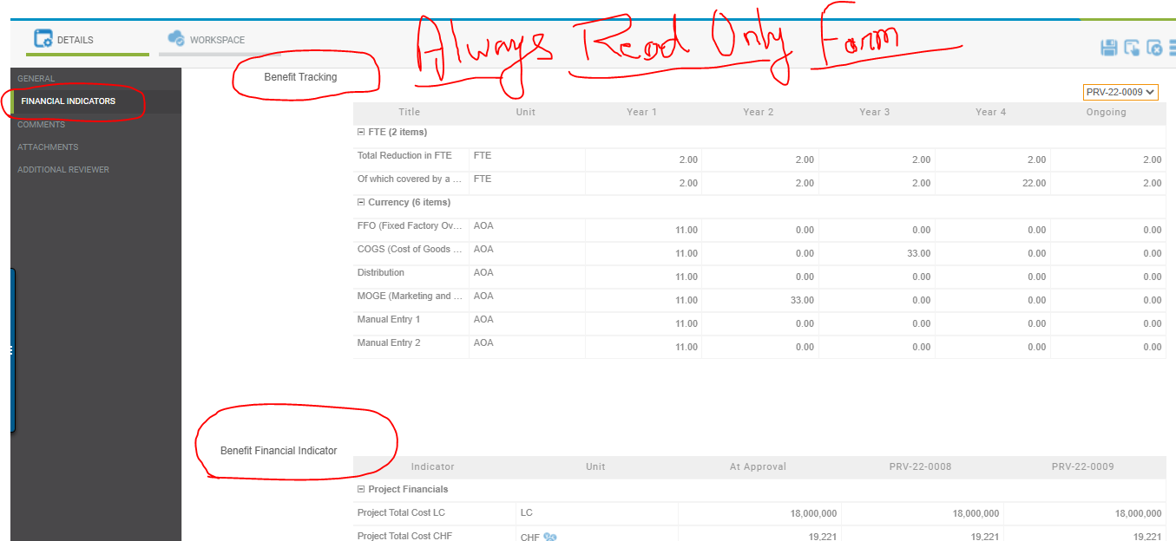

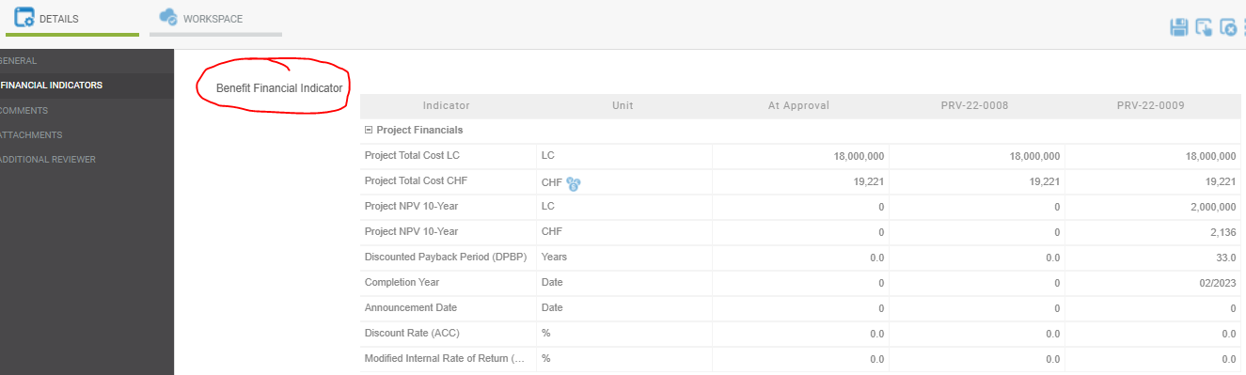

**Thank You…………s**